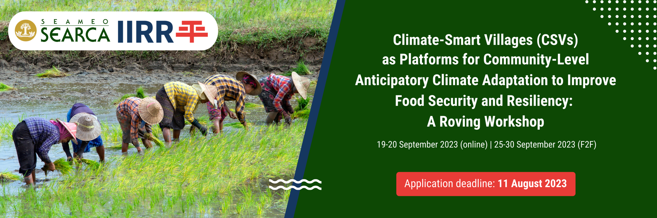

STATEMENT OF COMMITMENT

I, (Name of Participant), understand that sustained participation in the “Climate-Smart Villages (CSVs) as Platforms for Community-Level Anticipatory Climate Adaptation to Improve Food Security and Resiliency: A Roving Workshop” on 19-20 and 25-30 September 2023 is a requirement to receiving a Certificate of Completion and for gaining the most benefit from the learning event.
I hereby commit to participating fully in the roving workshop by attending all sessions and refining my initial re-entry action plan (REAP).
I have obtained the prior permission and commitment of support from my superior.
I understand that if, for any reason, I cannot perform any of the above, I will not be awarded the Certificate of Completion; and that my failure to fulfill this commitment will jeopardize the acceptance of my colleagues from [Name of Affiliation/Organization/Institution] in future training offerings of the organizers. If awarded a grant, SEARCA will also be constrained to withdraw it and I will need to reimburse the Center for the expenses incurred for my participation in this learning event.

Signature over the printed name of Participant | Signature over the printed name of Immediate Supervisor  Designation: ____________________
Date Signed: _____________________ | Date Signed: _____________________

